**Task 6**

**Performance test for the module of urbanladder using Jmeter on AWS cloud**

Launch Jemter and select recording template and do the required configuration setup

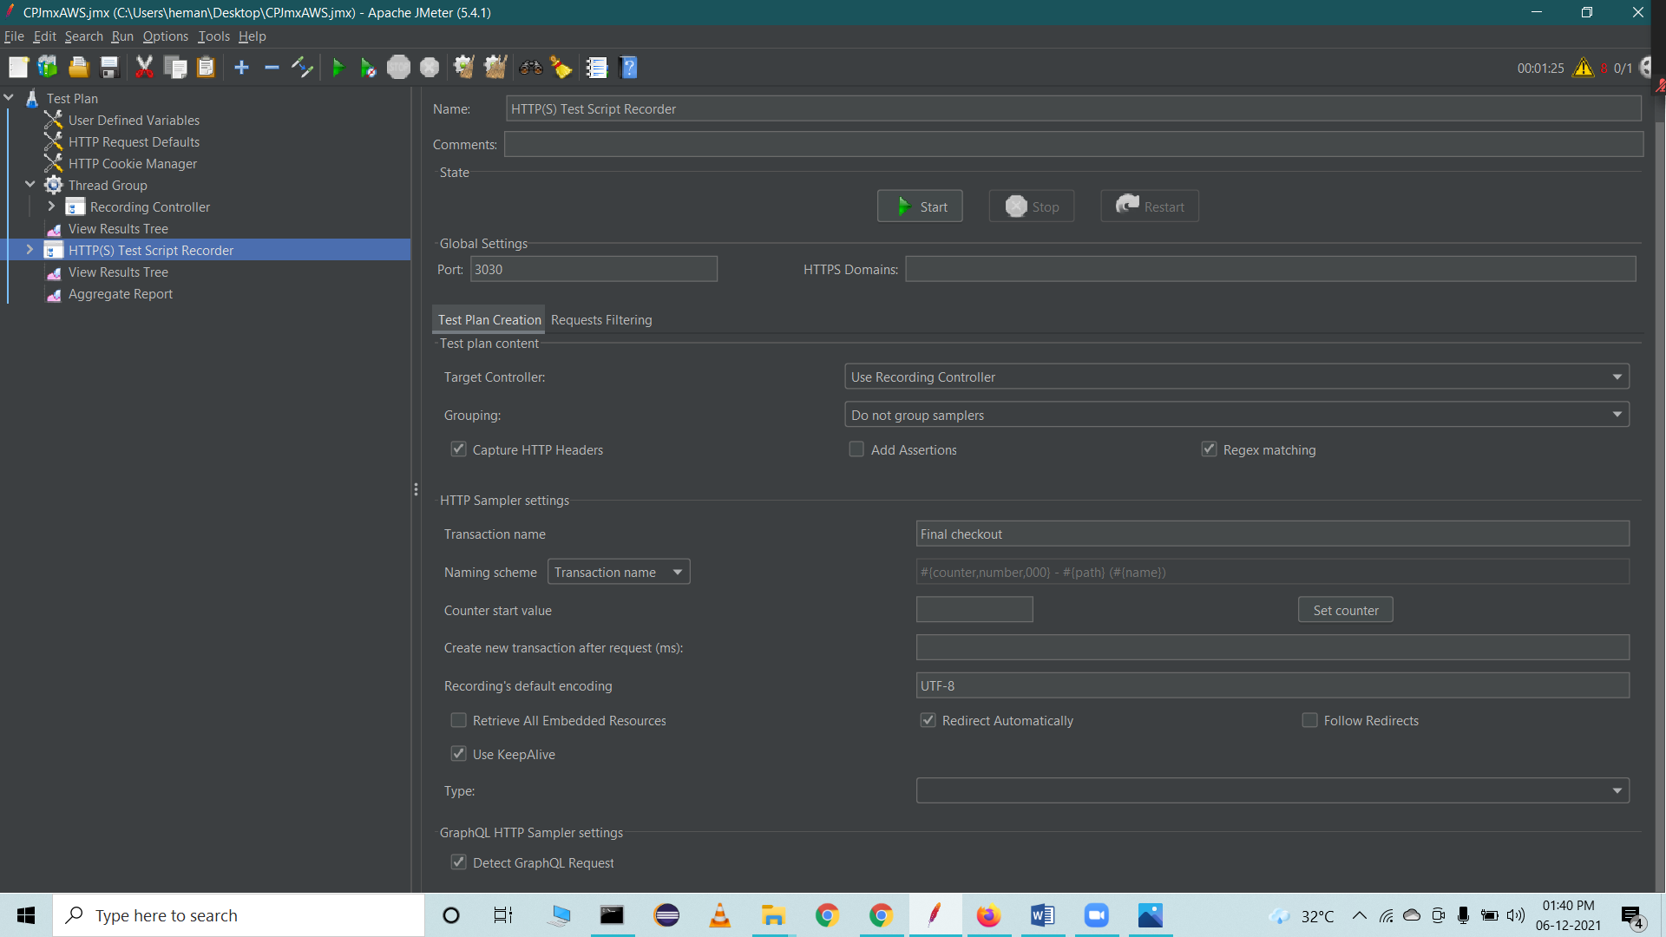

Start recording to capture the Http requests that we perform on the webpage ([www.urbanladder.com](http://www.urbanladder.com)).

Inspect and traverse various sections of Living module in urbanladder website and locate different sections.

We performed multiple operations in the webpages of that website and recorded are all Http request events from launching to checkout section

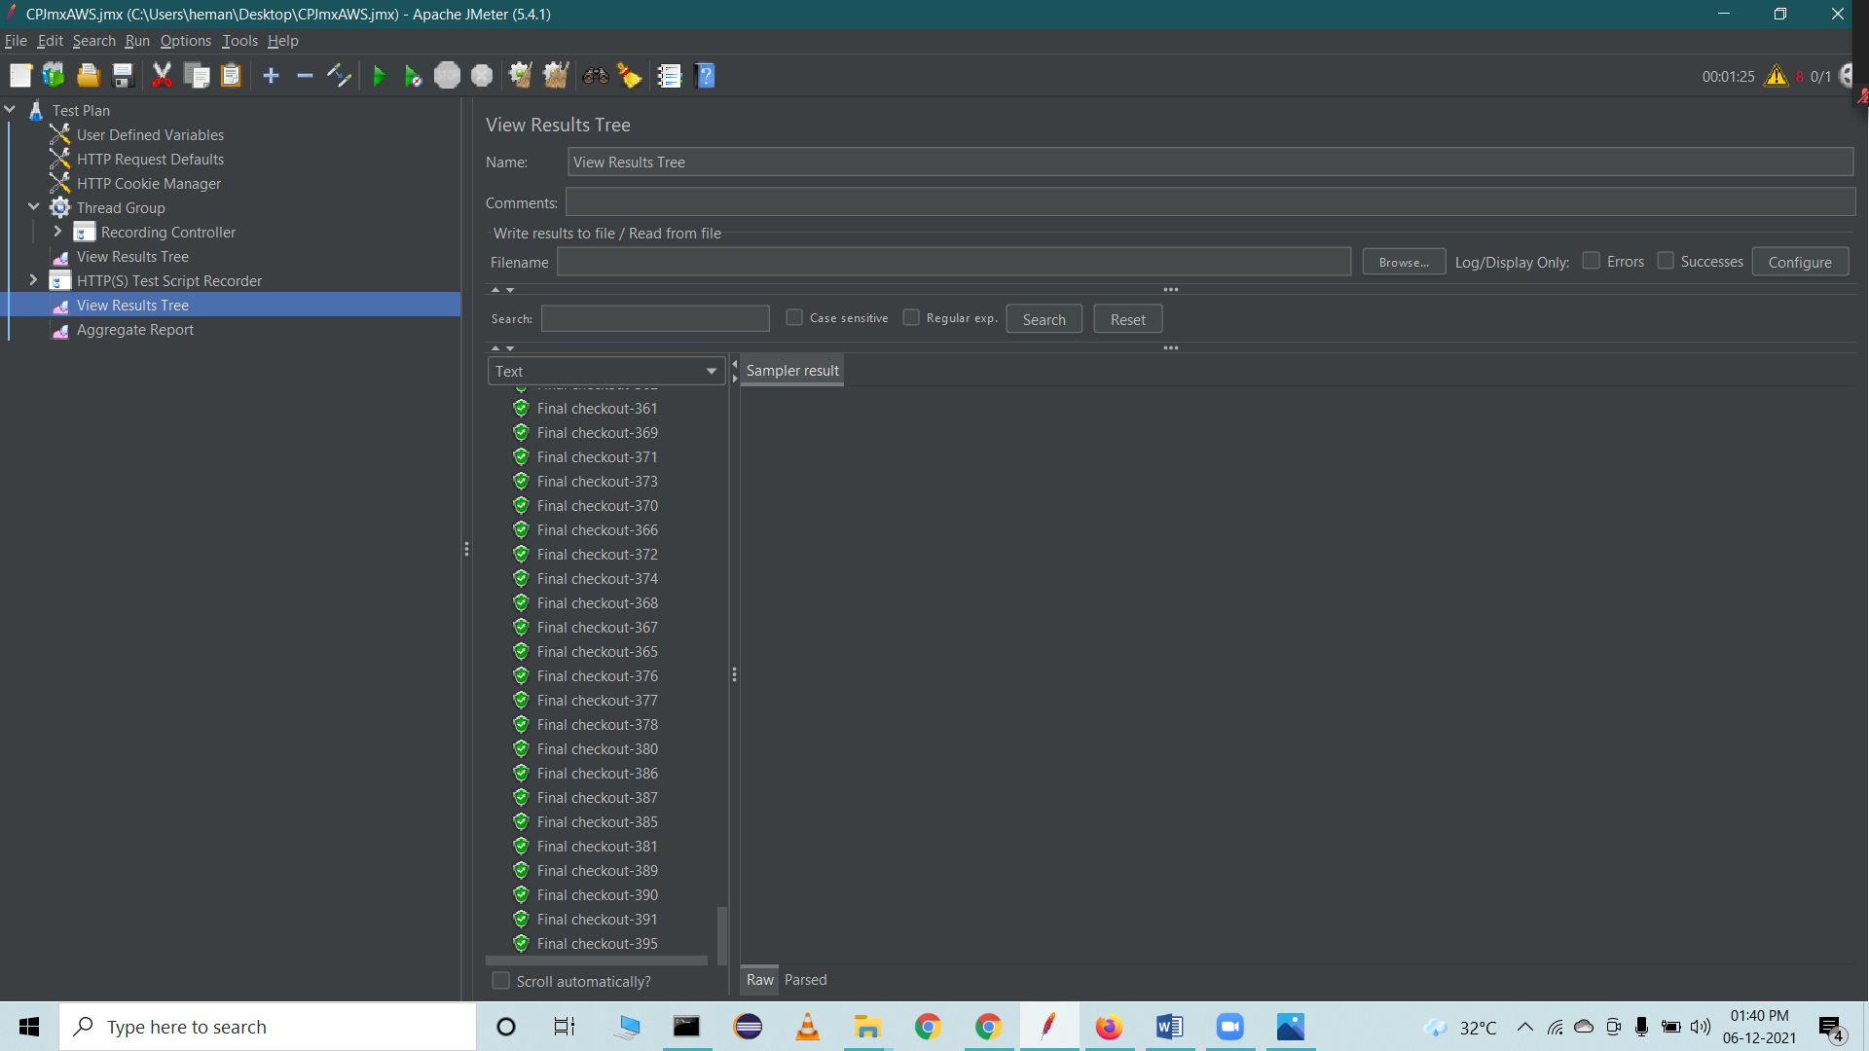

Save the Jmx file and use it in AWS cloudfromation template to perform load testing

Search for Load testing on AWS

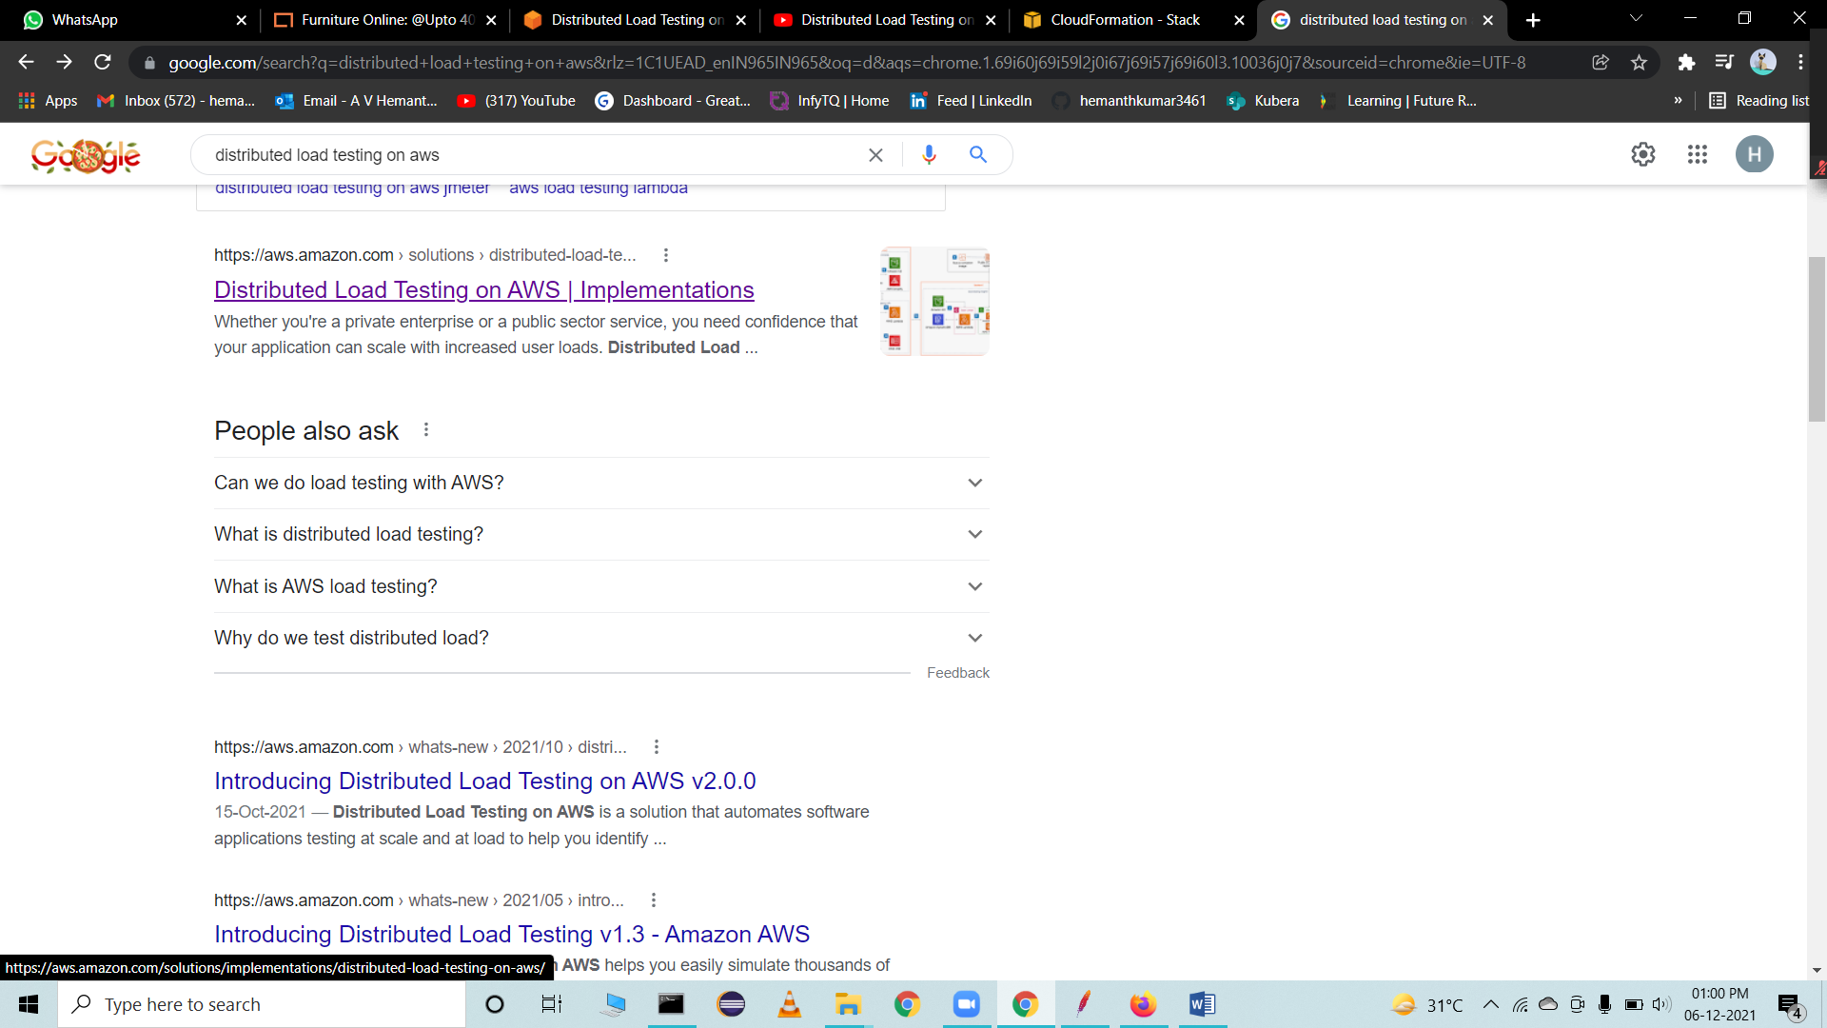

Go to home page

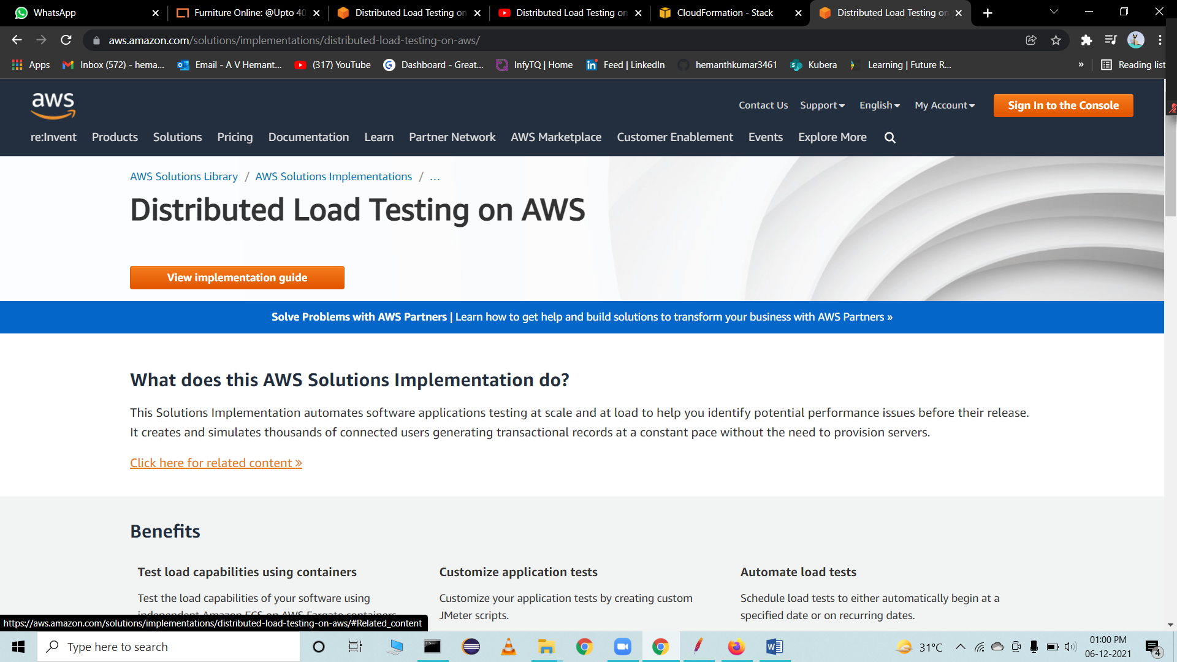

Click on cloudformation template

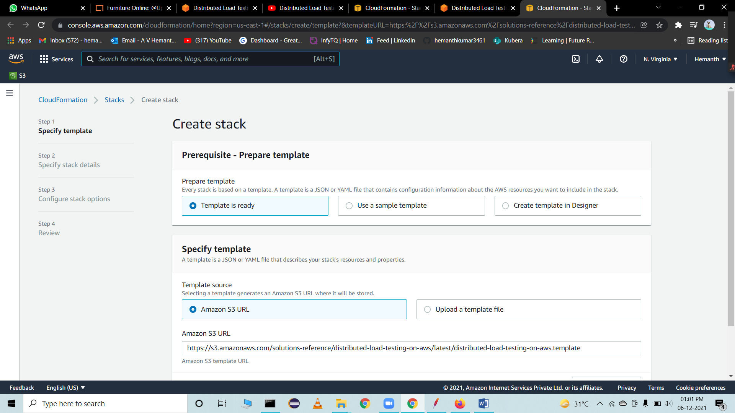

Configure the stack setup

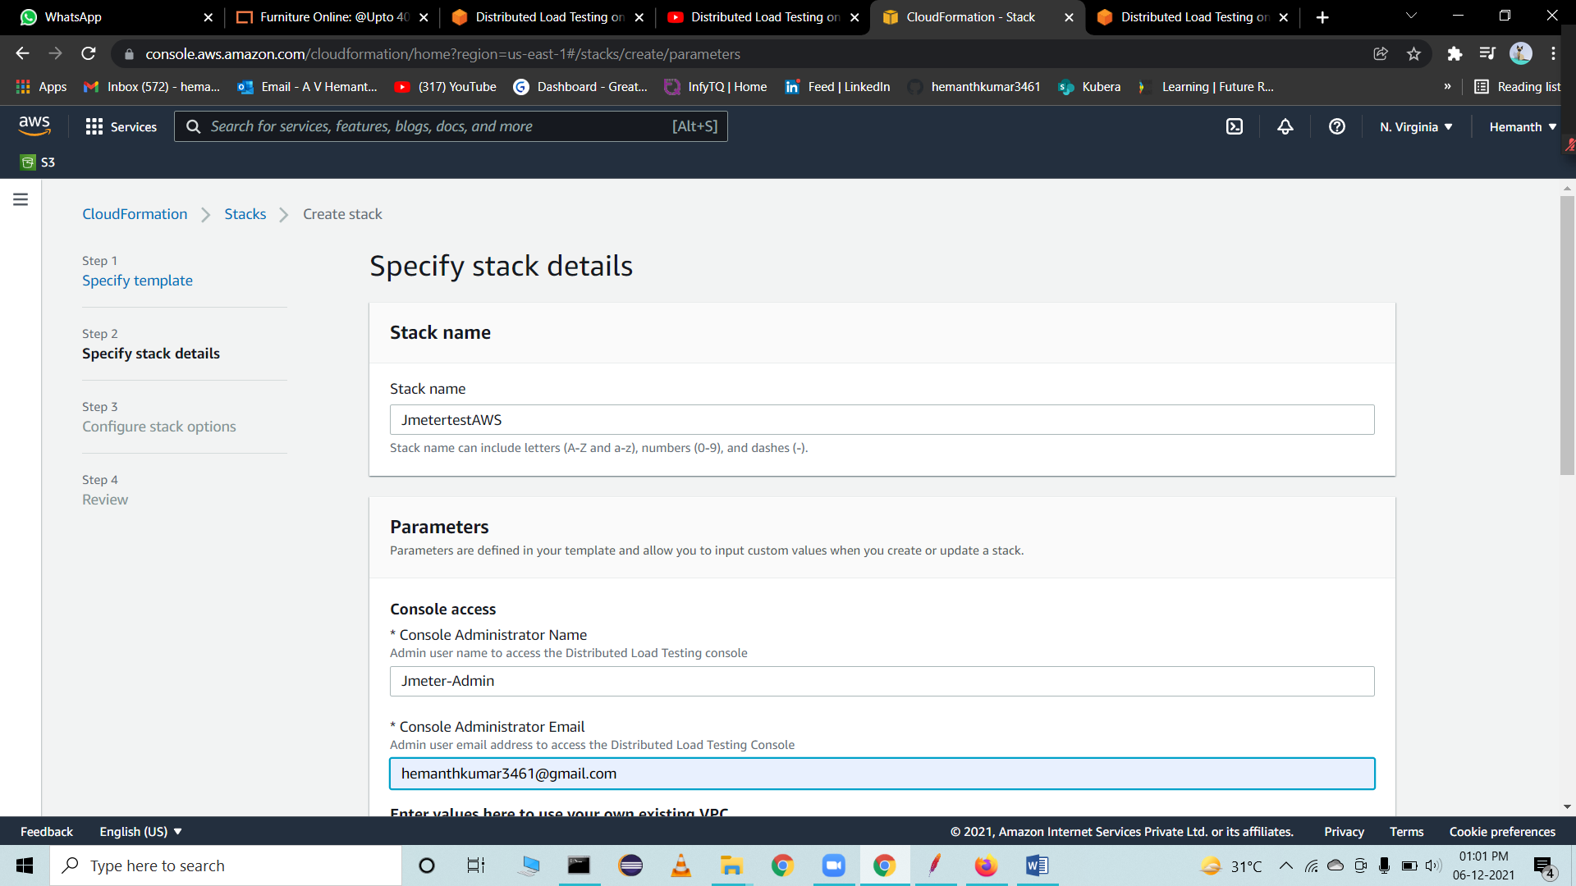

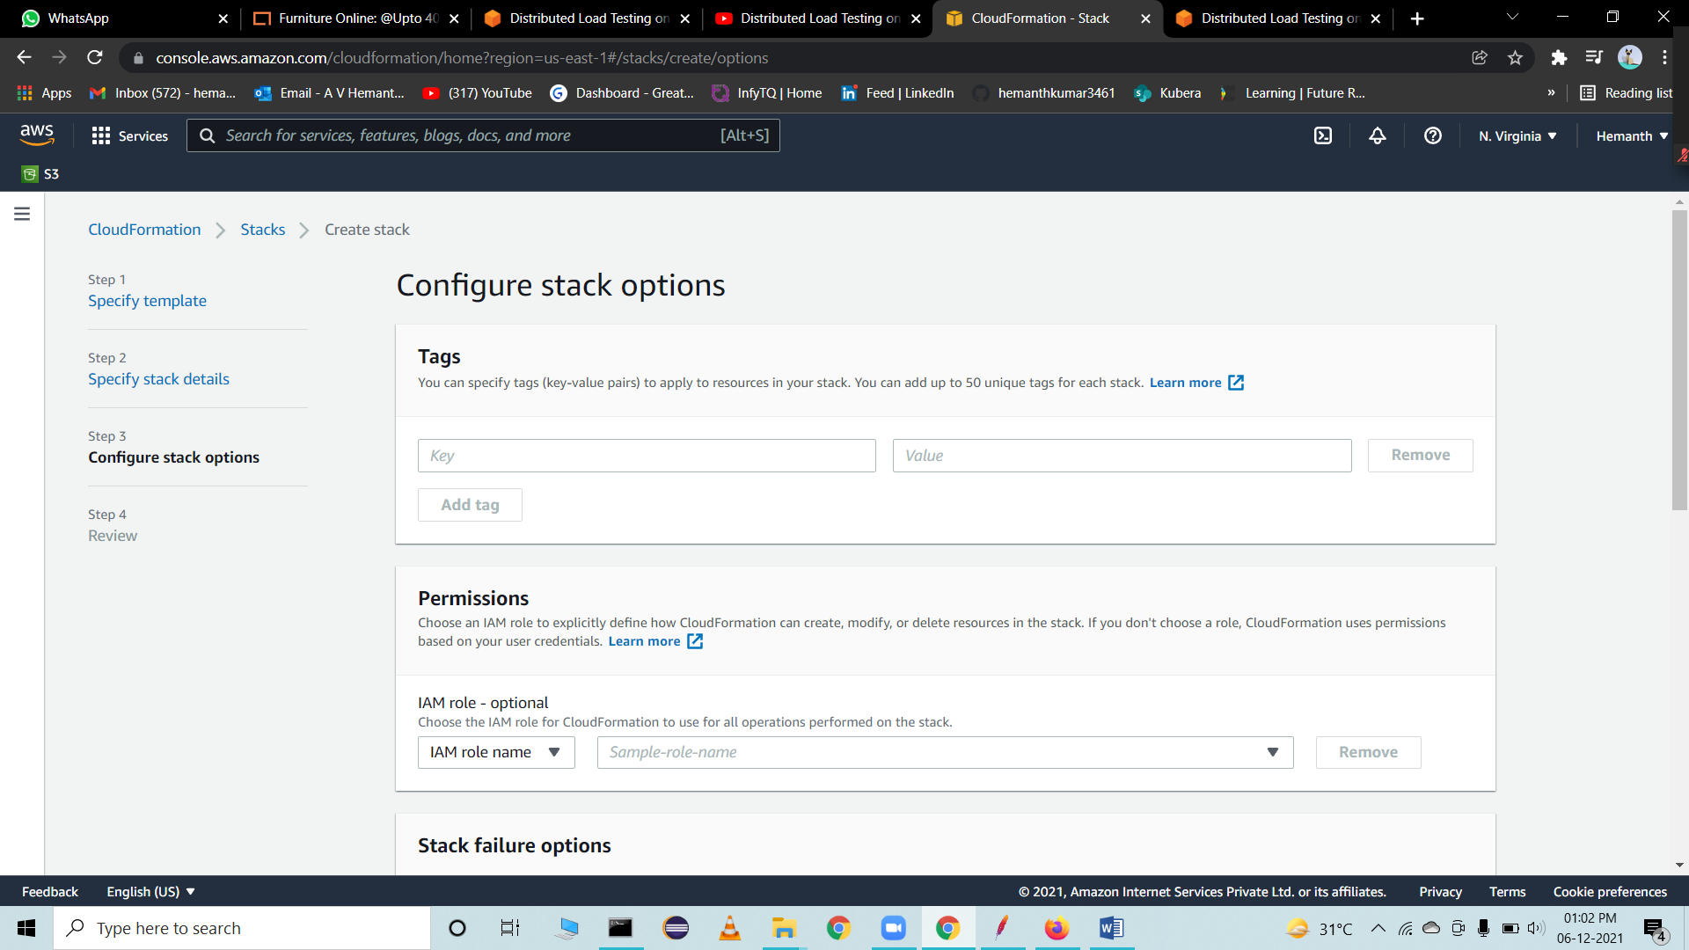

Provide all the default setup and click on create stack



Click on create stack

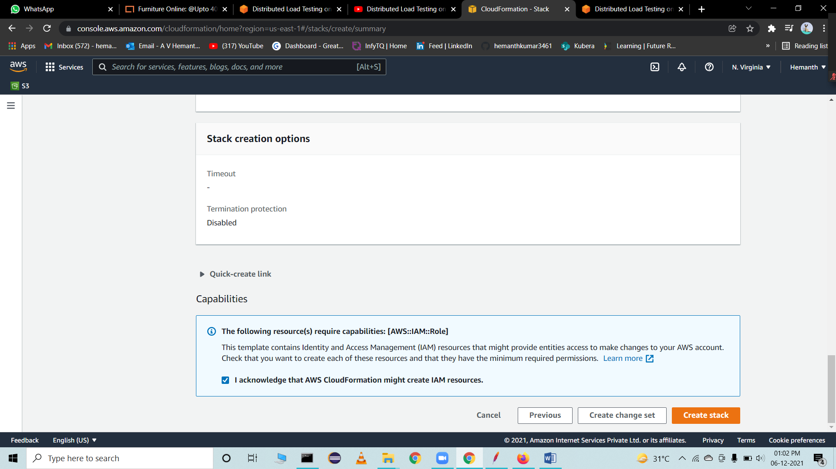

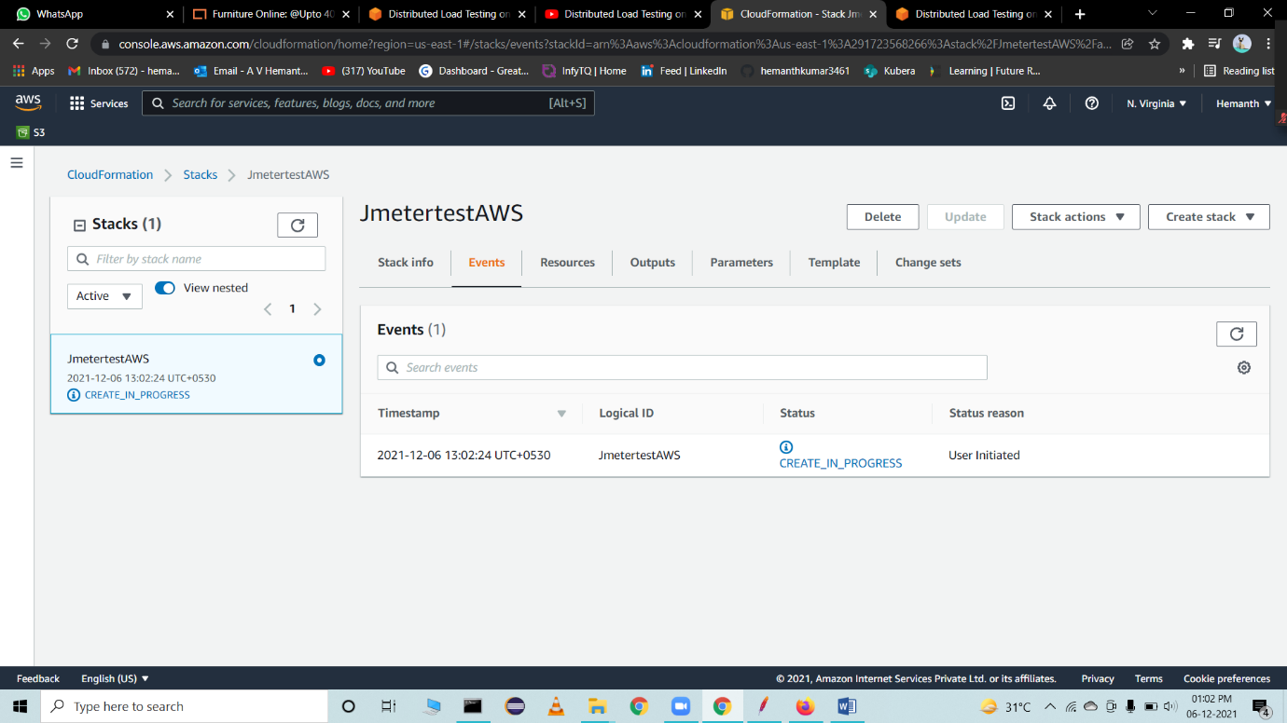

The process of creating this stack takes around 15 min

Once its created, you will receive the Url, Username and Password to the provided mail ID.

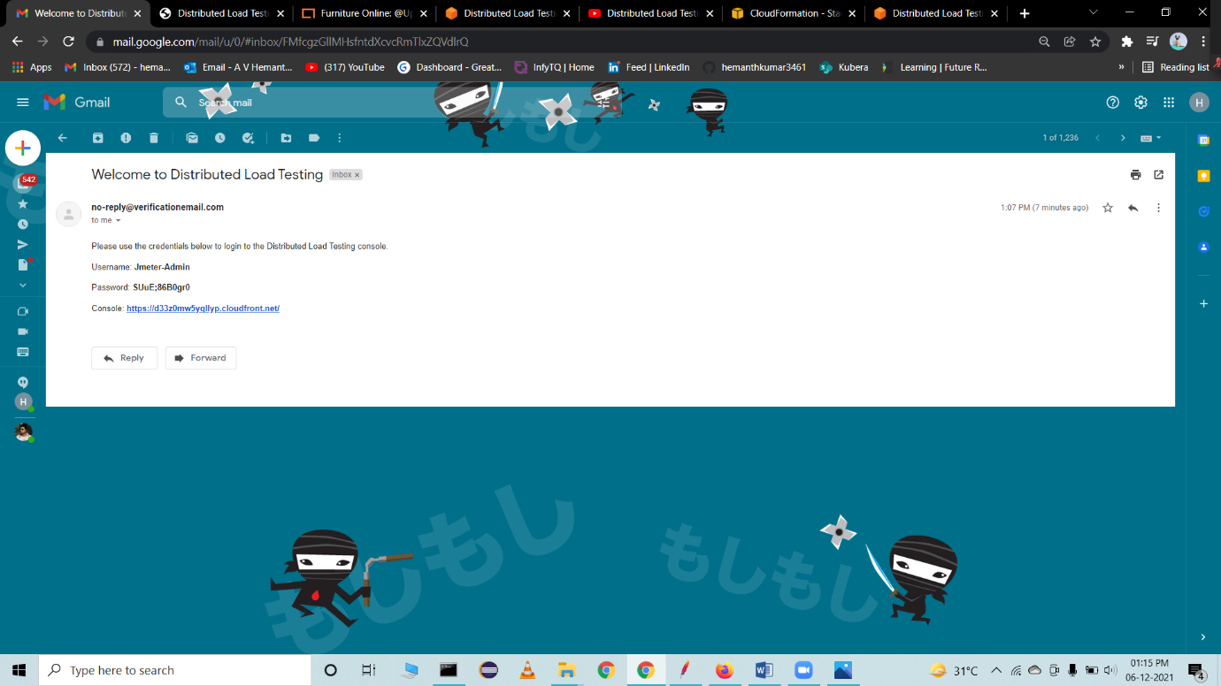

On-Click URL

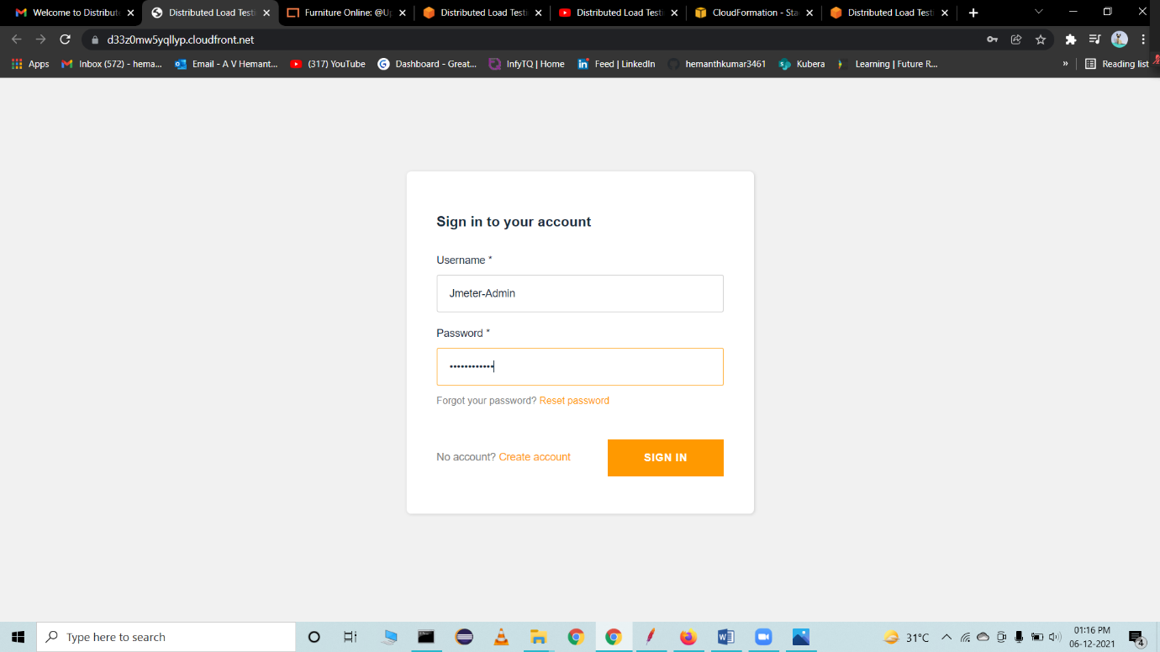

Click on Generate test

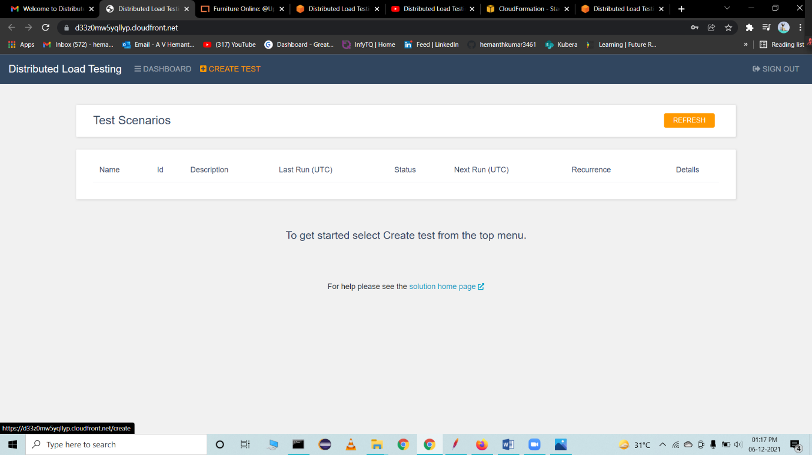

Here, we can create our test and configure the setup like number of dockers, Users etc.

Fill the required details for performing load test

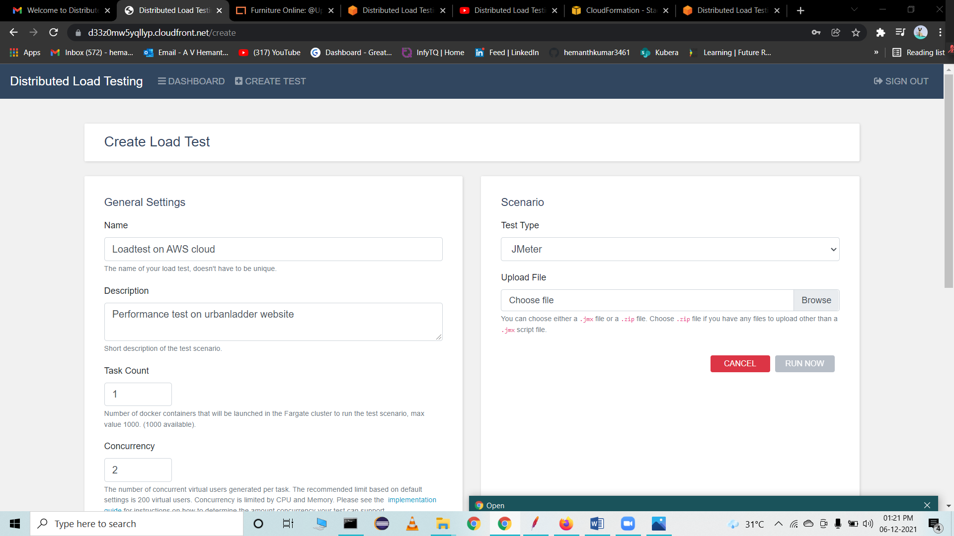

Choose the right Jmx file

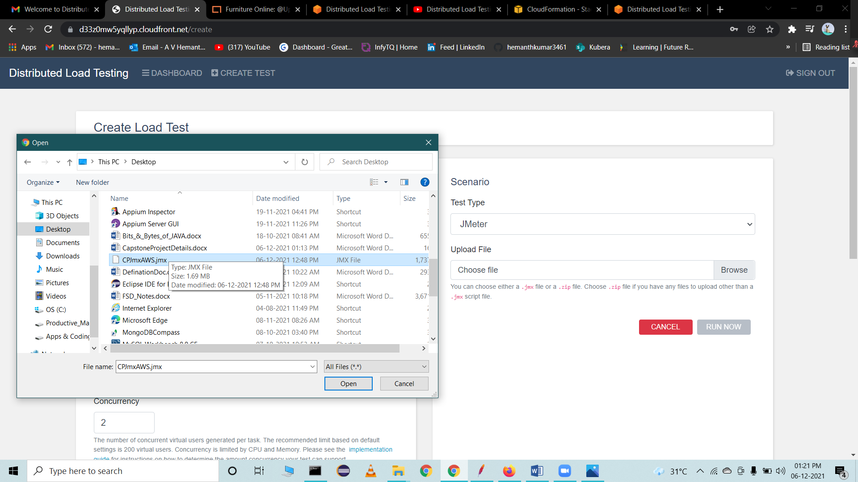

Click run now to start the test

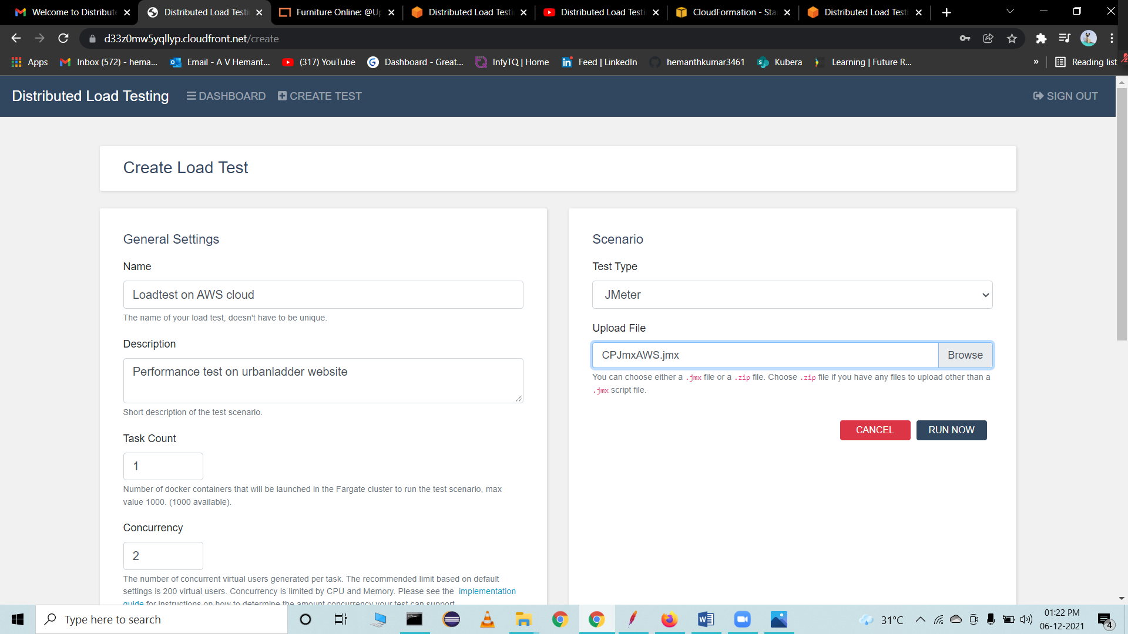

Keep refreshing and see the results

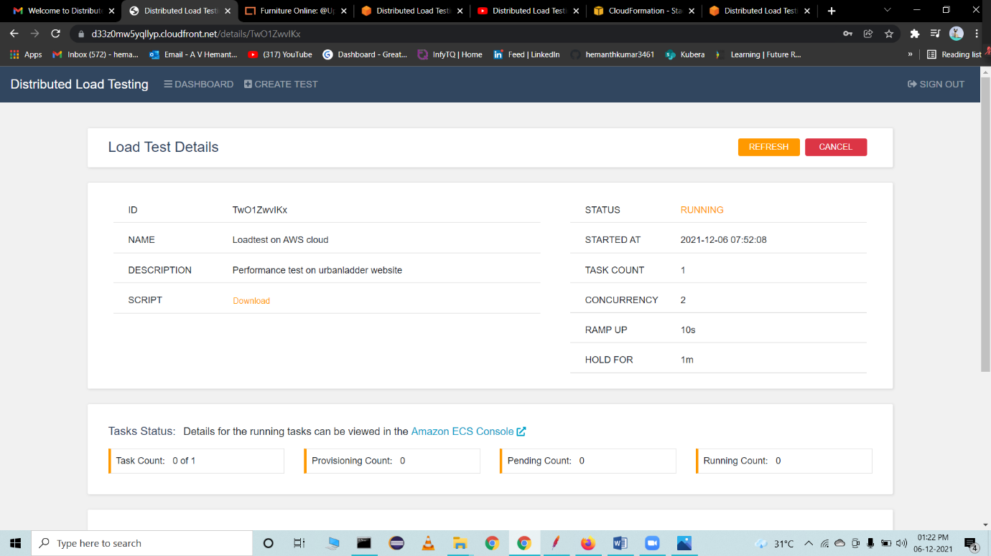

Open cluster to see more details on execution

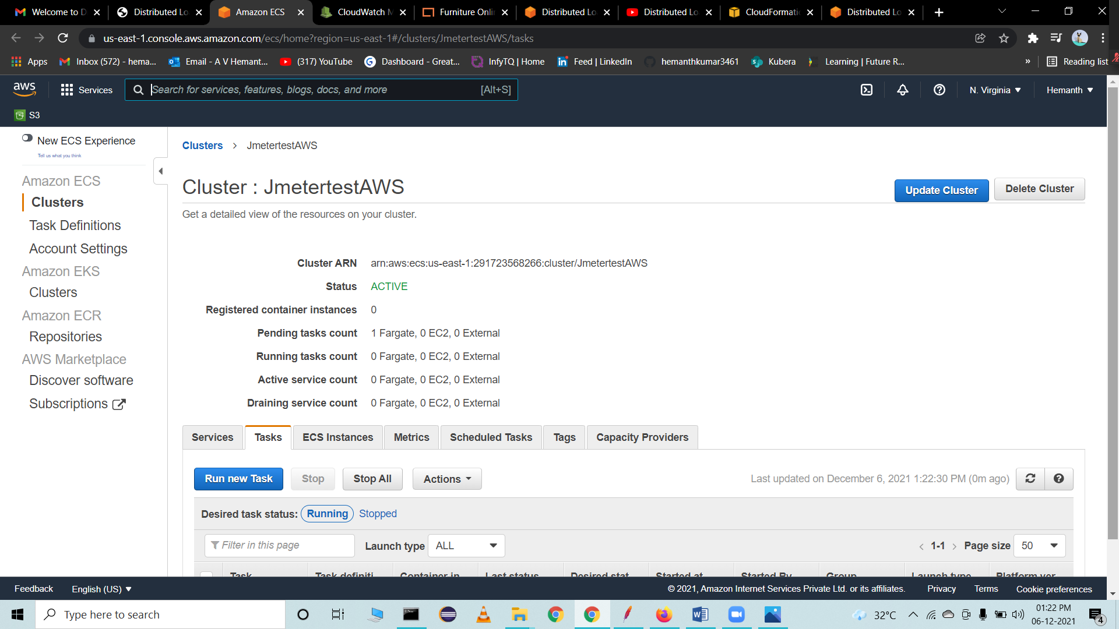

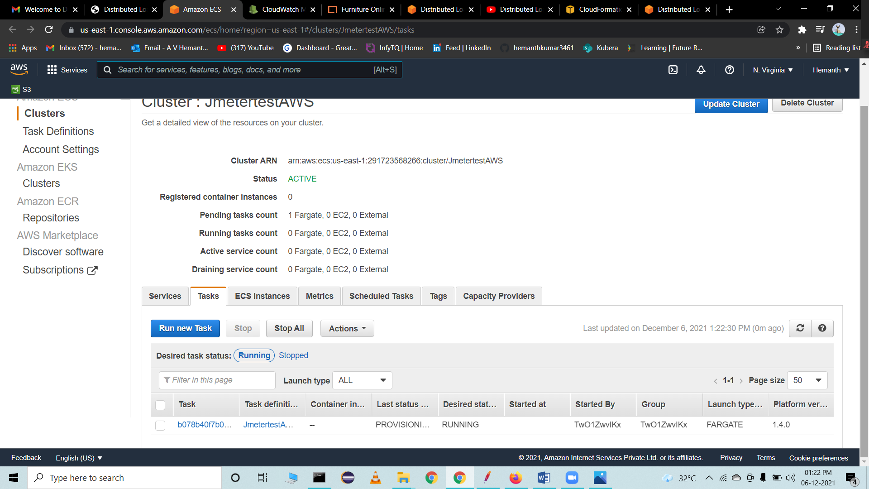

Observe the metrics on cloudwatch

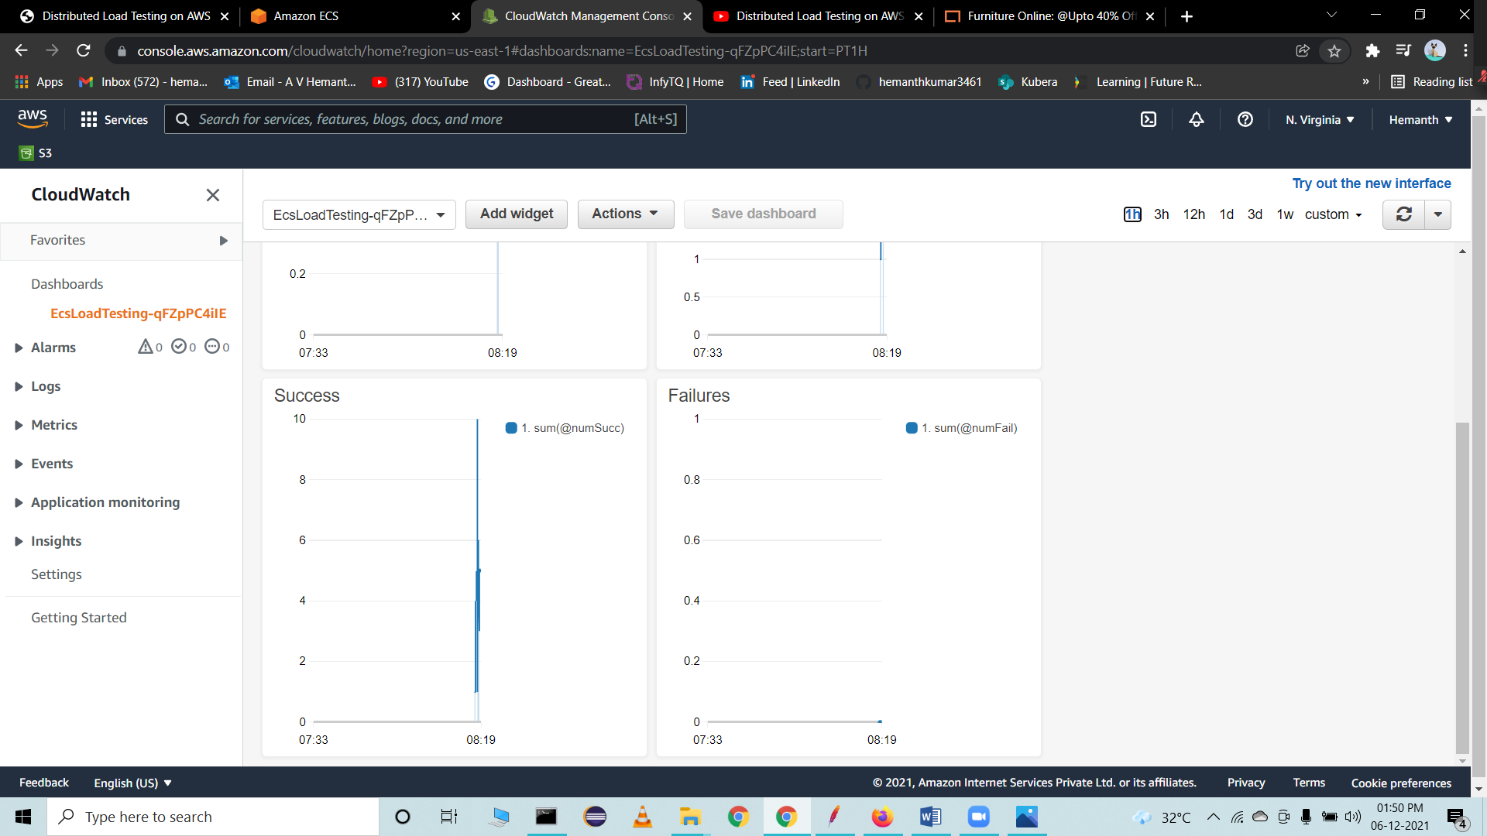

Observe the load test details

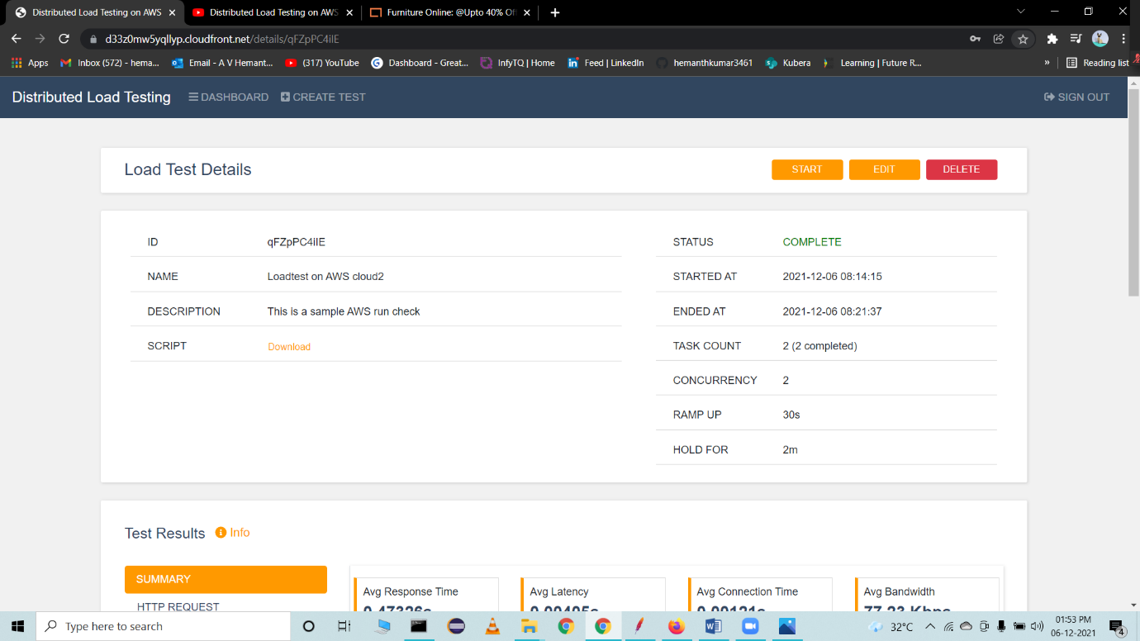

Status of all load tests performed

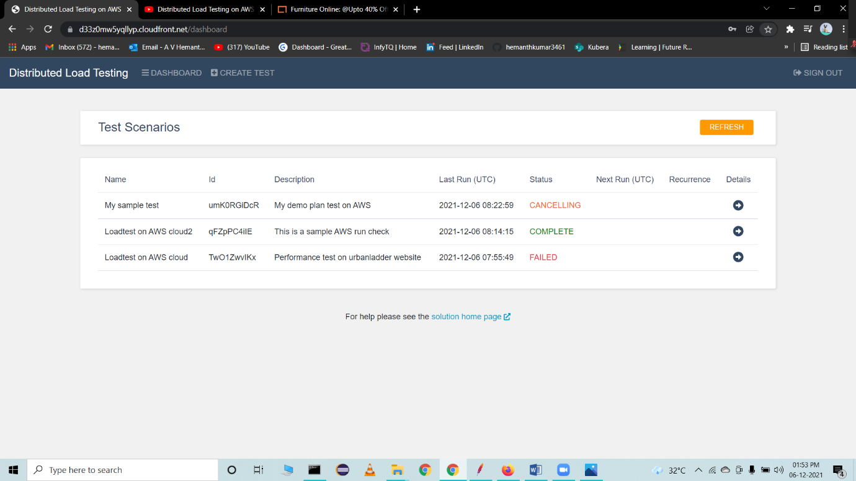



Test results

